

**The University of Azad Jammu and Kashmir, Muzaffarabad**

|  |  |
| --- | --- |
| Name | Kamal Ali Akmal |
| Course Name | Computer Architecture and Logic Design |
| Submitted to | Engr. Sidra Rafique |
| Semester | 2nd |
| Session | 2024-2028 |
| Roll No | 2024-SE-38 |
| Lab No | 04 |

Department of Software Engineering

**DE Morgan’s law**

**Procedure:**

1. At first construct the circuits shown in Boolean laws.
2. Check if the laws are valid. Give truth tables for each law.
3. Apply various combinations of inputs as shown in the truth table and observe the conditions of LEDs.

(A + B)' = (AB)’…………(i)

(AB)’ = A’ + B’…………...(ii)

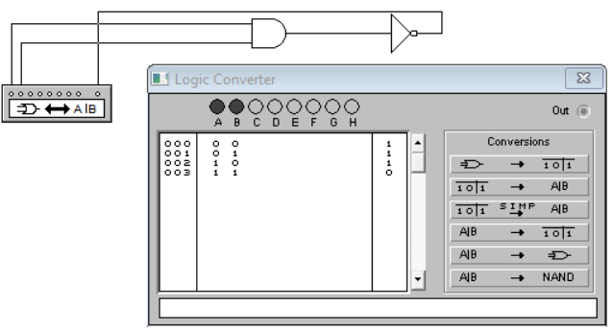

. .…**is equivalent to …**

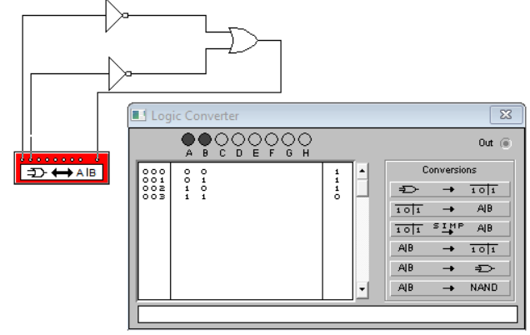

(AB)’ = A’ + B’

(1 * 0)’ = 1’ + 0’

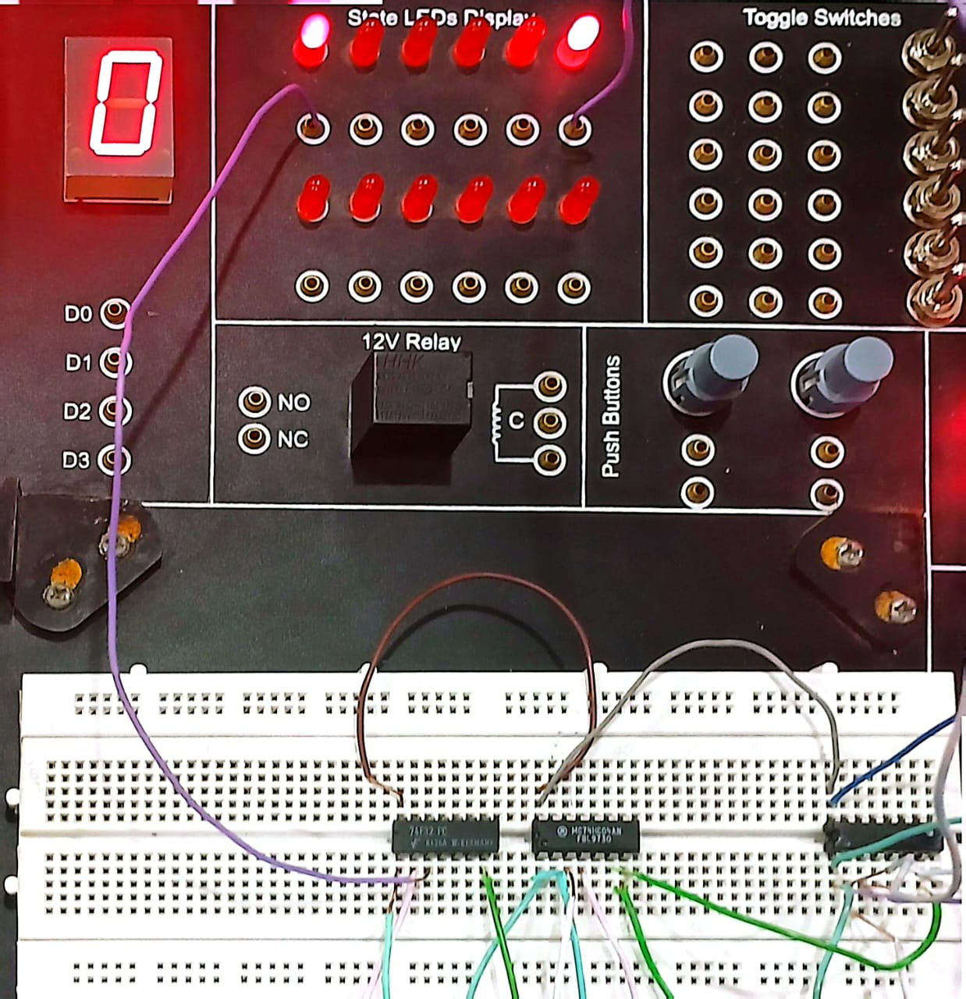

(A + B)' = (AB)’

(1 + 1)’ = 1’ * 0’

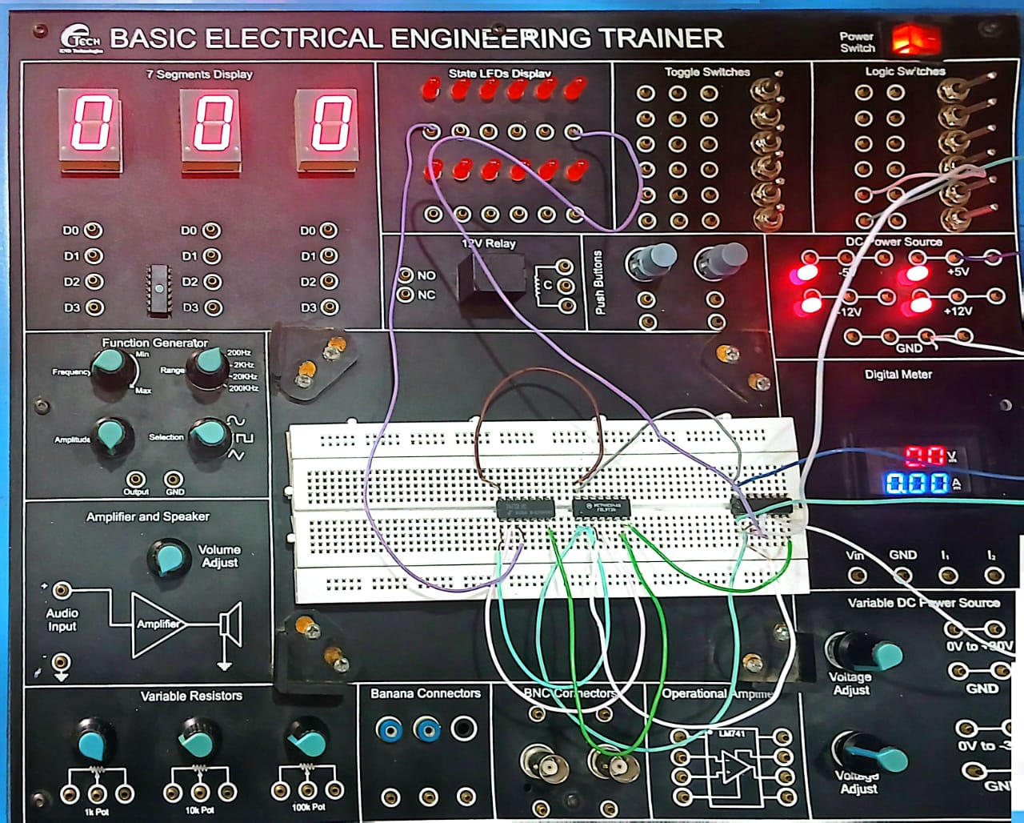

(AB)’ = A’ + B’

(0 * 1)’ = 0’ + 1’

